**Calorie Tracker**

**Problem Description**

We wish to create a website for users to track daily calorie intake and exercises. We will be building a calorie-tracking app that allows you to monitor how much you are eating and how many calories you are expelling through exercise. It will be mobile-based but may also have web-browser capabilities.

The functions of this app include but are not limited to:

1. View caloric intake at-a-week’s glance
2. View breakdown of your calories for the current day
3. Log food for breakfast, lunch, dinner, and snacks
4. Log exercise
5. Set goals
6. Create a profile
7. View trends over time by looking at graphs within the app (can look at daily, monthly, yearly depending on use)
8. Compare user demographics within app

**User Vignettes / Use Cases**

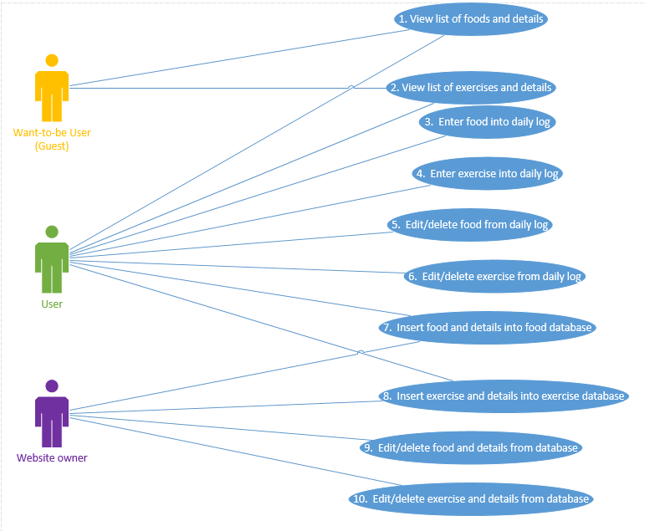

Want-to-be Users will have very limited accessibility to using the interface and adding to/editing the databases. Want-to-be users should be able to only view lists of food and details and view lists of exercises and details. Users own the specific part of the data that store their daily logs. Therefore, users should have full control over their own personal daily log and have some accessibility to the databases. The user should be able to view lists of food and details, view lists of exercises and details, enter food into their daily log, enter exercises into their daily log, edit/delete food from their daily log, edit/delete exercises from their daily log, insert food and details into the food database, and insert exercises and details into the exercise database. The Website owner will have full control of the websites databases to include adding and deleting from the databases. The Website owner should be able to insert food and details into the food database, insert exercise and details into the exercise database, edit/delete food and details from the food database, and edit/delete exercises and details from the exercise database.

**Database Design**

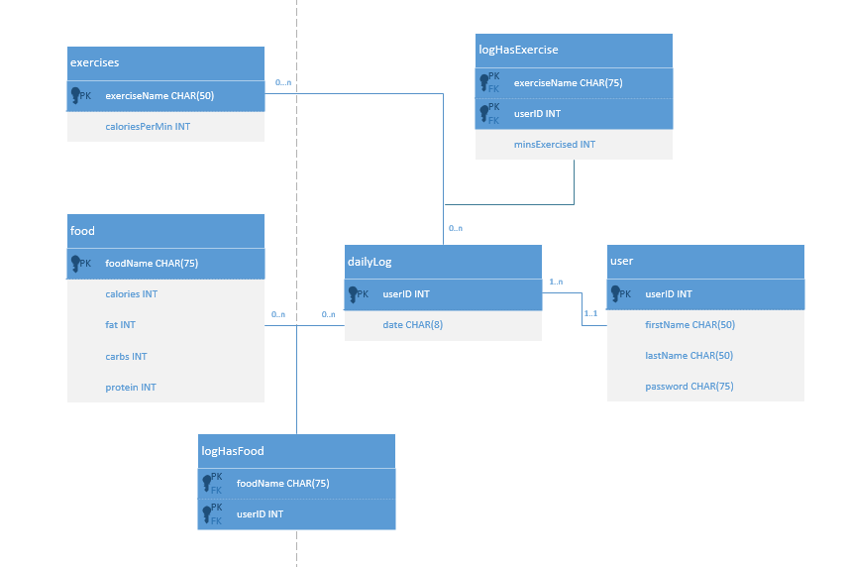

**Interaction Design**

